Git

Parido por Linus Torvalds + gente de la comunidad Linux

Sistema de control de versiones que, como tal, permite :
- Mantener tracking de cambios (no por diff, sino con snapshots)
- Comparar versiones
- Retroceder versiones
- Etiquetar versiones
- Aparcar versiones temporalmente (stash)
- Trabajar con branches, + merge …
- Excluir ficheros del tracking (con .gitignore)
- etc…
$ git init # Initialize a new git database
$ git clone # Copy an existing database
$ git status # Check the status of the local project
$ git diff # Review the changes done to the project
$ git add # Tell Git to track a changed file
$ git commit # Save the current state of the project to database
$ git push # Copy the local database to a remote server
$ git pull # Copy a remote database to a local machine
$ git log # Check the history of the project
$ git branch # List, create or delete branches
$ git merge # Merge the history of two branches together
$ git stash # Keep the current changes stashed away to be used later
..etc …

Git es un Sistema de control de versiones DISTRIBUIDO : No hay forzosamente un repositorio centralizado, sino que todos los componentes de un equipo de trabajo trabajan sobre su PROPIO CLON LOCAL. No obstante, suele seguir existiendo un repo común, por convención, por costumbre … (habitualmente en GitHub, o en un srver corporativo)

Git es un “Three (or six) States” system. :
- The working directory is just the current snapshot that you are working on.
1.1 Ficheros no trackeados (nuevos, para los que nunca se hizo un git add
1.2 Ficheros trackeados (tras hacer un git add en algún momento de su vida)
1.2.1 ...pero ignorados usando .gitignore
1.2.2 No ignorados
1.2.2.1 No modificados
1.2.2.2 Modificados → modified
- The staging area is where modified files are marked in their current version, ready to be stored in the database. (git add) → staged
- The git directory is the database where the history is stored. (git commit) → commited

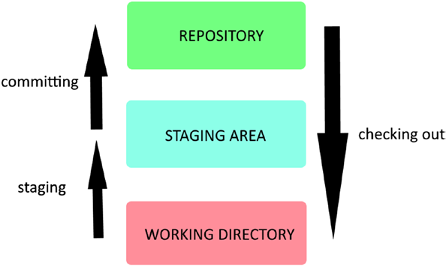

2 formas de crearnos un repositorio LOCAL :
- Situarse en una carpeta y ejecutar $git init. Creará un subdirectorio .git. Es para uso interno de git.
- Clonar un repo remoto con $git clone https://github.com/Kalimero704/CursoPython
(O, para ambas cosas, y muchas más, utilizar GitHub Desktop -para Win y Linux-)
Esa carpeta de nuestro proyecto la podremos luego manejar, por supuesto, con Eclipse, VSCode, ...etc.
Los IDEs serios sabrán incluso lidiar con esa subcarpeta .git y ofrecerán acciones para commit, etc… (Otra opción es usar para ello git en linea de comandos, o GitHub Desktop, o SourceTree, ...etc ).
Típico caso de uso :
- git clone https://github.com/Kalimero704/CursoPython
- git log

- git branch rama_ISSUE_1 (cra una rama a partir de aquella en la que estemos -puede ser master, … o no-)
- git checkout rama_ISSUE_1. Nos “posicionamos” en esa rama si no lo estuviéramos
Si no hacemos un checkout, aún estaremos trabajando en la rama ‘main’ !!!
(Nota : git branch a secas nos informa de los nombres de las ramas que tenemos, indicando coun un * aquella en la que estamos posicionados – la HEAD- )
( Si queremos borrar una branch, nos movemos primero a otra – así nunca podremos quedarnos sin ninguna-, y luego hacemos git branch -d nombre )

- … modificar ficheros … probar bla bla …
- git diff [file.ext] (si queremos ver qué hemos cambiado hasta ahora y no estageado aún)
- git add ficheros de esa-cosita-cambiada (los pasamos a staged)
- git rm --cached fichero-a-desestagear (este lo quito de staged, con lo que luego no entrará en el snapshot al comitar)
Los 4 pasos anteriores se pueden repetir n veces, obviamente..
Se van estageando ficheros concretos o grupos de ellos, y luego más adelante se commitarán todos ellos de golpe (pero ojo !!! : sólo los staged).

- git status
Importante ver si hemos creado/modificado cosas y nos hemos olvidado de hacer un add, pues en tal caso serían IGNORADAS por el commit posterior !!!.
git status nos avisa de cambios no stageados, p. ej…

- git diff --staged , para echar un último vistazo anter de commitar !!!!

- git commit -m “Hemos cambiado la cosita para bla bla..”
Pasamos los ficheros staged (sólo ellos) a commited, pero aún en NUESTRO repo local. Se creará un snapshot de la rama en la que estamos trabajando, o de todo el proyecto (carpeta) !?!?
Cada commit genera un nuevo snapshot, que se identifica con un hash SHA1.
El snapshot anterior pasa a ser el parent del nuevo. (Excepto el primero -tras git init-, todos los snapshots tienen un parent. Y si un snapshot tuviera 2 parents, es por ser el resultado de un merge).
El snapshot nuevo pasa a ser el HEAD.
- git revert (si quisiéramos retroceder un commit). Un revert genera un nuevo commit con los cambios opuestos a lo que estamos revirtiendo, y se supone que lo comitado antes volvería a estado de stageado...

- Opcionalmente, hacer pull requests a remoto para que otros puedan revisar. Si hay feedbacks… etc … volver al punto 4
Ahora que hemos terminado con esa rama, querremos mergearla con aquella de la que provenía (en nuestro caso, master) :

- git checkout master (nos posicionamos en la rama receptora del merge)
- git pull origin master (… y la actualizamos – por si otros hubieran hecho cambios mientras tanto- antes de subir lo nuestro !)
- git merge rama_ISSUE_1
- git log --oneline --graph

- Hacer un pull request a remoto para que otros puedan revisar. Si hay feedbacks… etc … volver al punto 2
- Bla bla

- git push (para subir al repo remoto en GitHub, p. ej)
- git pull (para actualizarnos localmente a partir del remoto)
Nota : estas operaciones push y pull están siendo baneadas desde 2021 :
remote: Support for password authentication was removed on August 13, 2021.
remote: Please see https://docs.github.com/en/get-started/getting-started-with-git/about-remote-repositories#cloning-with-https-urls for information on currently recommended modes of authentication.
Conviene hacerlas ya con herramientas visuales tipo GitHub Desktop, SourceTree, ...etc
Notas sobre el .gitignore (para excluir ficheros y/o carpetas del tracking de git).
1. Podríamos tener un .gitignore en cada subfolder, pero se considera una mala práctica. Mejor tenerlo sólo en la carpeta raíz del proyecto
2. El propio fichero .gitignose SI se ha de trackear. Conviene hacer, por tanto, un git add .gitignore.
3. Qué meter en .gitignore ?
Well, the rule of thumb is to ignore all files generated by the project. For example, if your project is a software source code, you should ignore the compiled outputs (executable or translated files). Temporary files and logs should also be left out, along with big libraries (node_modules). And don’t forget to exclude all your personal configs and your text editor’s temp files.
If you are using a computer language or framework, you can go to https://github.com/github/gitignore to get a template of the .gitignore file you should use.
4. Se pueden poner excepciones (precediendo el patrón con un !)
P. ej si la regla de exclusión es *.exe, DESPUES podemos indicar !output/main.exe. → Este .exe SI será trackeado.
5. Ejemplos de patrones :
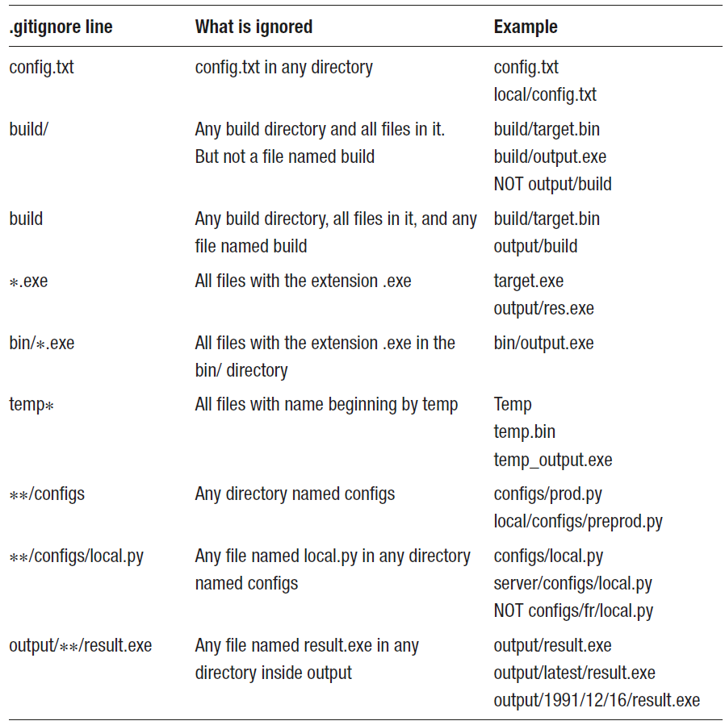

Opciones para filtrar el log (git log):
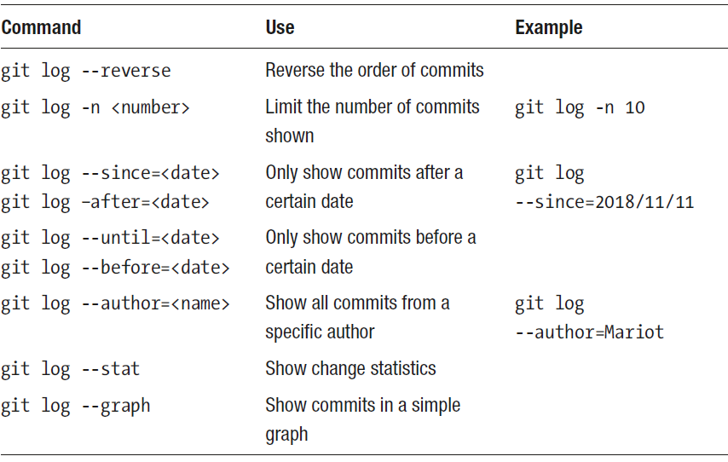

Una típica salida de log sería, p. ej…
( El numerajo hash en amarillo es el que se debería utilizar con git show para saber los cambios de ese commit )
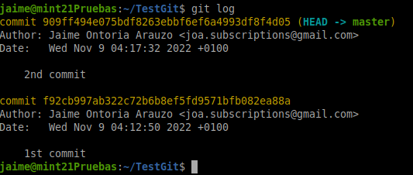

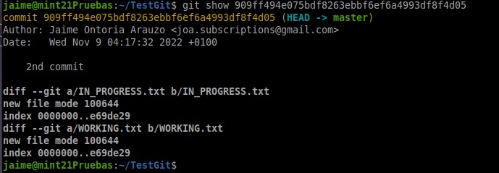

checkout
!?!?!? Ojito, que no es lo mismo para commits que para ramas !?!?!?!?
Si no nos conformamos mirando los logs con saber qué se tocó hace tiempo sino que queremos revisarlo bien y manosearlo, en todo momento podemos navegar a ese snapshot o esa otra rama. !?!?!?
Se hace un git log + git show y cuando tengamos claro qué versión queremos recuperar, se hace un git checkout del identificador de ese commit concreto. P. ej, $git checkout 9f180aa
Ojo !! Se perderá todo aquello modificado que no hayamos commitado, y será sustituido por el snapshot que estamos checkeando !!
Además … Be careful not to change anything when checking out previous commits. Just like in the movies, changing the past is a very bad idea!

Por cierto la referencia al snapshot que tenemos en el dir de trabajo se llama HEAD, creo.

En algún momento querremos volver a tener en nuestro directorio de trabajo la última versión otra vez.
Bastará con hacer un checkout de master : git checkout master

- Two golden laws of time travel:
• Only travel back in time when the present is clean (nothing unstaged in the working directory).
• Don’t change the past (until you have more experience).

Don’t forget to check out the current branch (master) after navigating between versions.

revert
Con $ git revert <commit name> se puede revertir cualquier commit hecho.
Hay que tener la prevención de , como en el caso de los checkouts no tener antes nada pendiente de comitar (Hacer git status… etc).
Un revert genera un nuevo commit con los cambios opuestos a lo que estamos revirtiendo.
Por tanto,
a) Se nos preguntará por un mensaje explicativo. P. ej, “Revertimos la cagada de marzo...”
b) Este commit aparecerá en los logs ...

Obviamente, se puede hacer un revert de un revert..

commit –amend
Bla bla …

stashing

Many times, you will want to navigate between branches but can’t because your Working Directory is dirty. In this context, dirty means that you have uncommitted changed files, be they in modified or staged state. The only way to change branch is to first commit them. But most of the time, you won’t be ready to commit yet because the issue at hand is not resolved yet.
One solution to this is to make a temporary commit, change branch, work on it, and then go back and amend the temporary commit. There are many problems attached to this method: first, your Working Directory will be clean when you commit, meaning that you won’t know anymore which files were being changed. Second, it’s a plain dirty and ugly method. That’s not why the amend command was created. The ideal solution is to use a technique called “stashing.” Stashing means taking any modified tracked file in your Working Directory and put it away for later. That means that you will have a clean directory and can navigate around your repository, without having to commit your changes. Those changes are stored in a little database called “stash.”
You can think of the stash as a temporary repository for your unfinished commits. It’s designed as a last-in first-out database, meaning that the last changes you stashed will be presented to you first.

git stash push
git stash list
git stash show
git stash pop

reset

$ git reset --hard origin/separate-code-and-styles
This command will erase EVERYTHING so the project can be brought back to a previous state.
Your commits made after the target state, your current changes, and staged files will all be deleted as the “--hard” option overwrites everything on its path. It’s the most dangerous command in Git and you should think hard before using it.
Resetting should only be done in the last resort. Prefer reverting the commit if possible or just straight-up continue to work on a new branch. When used carelessly, reset can destroy your data.
BRANCHES
Se recomienda no trabajar sobre la rama principal, sino sobre otras creadas explícitamente para resolver una issue, y sólo volcar a master cuando esté acabada. Así no impactaremos el trabajo de otros.. bla bla
Obviamente, las branches se pueden ramificar …

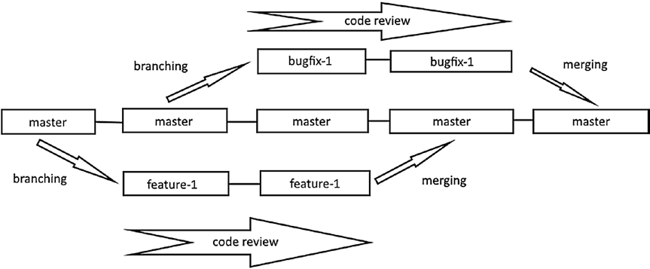

Branches típicas:
- La de producción o master
- Otra(s) para evolutivo
- Otras para issues… (cada issue, una branch diferente !!!!. No mezclar cosas… !
Conflictos en los merges
merging sometimes throws conflicts when the two branches contain edits of the same code. To resolve those conflicts, you have to reopen the concerned file and decide which code to keep. Then, the rest is basic: staging and committing.
Merge conflicts are one of those things that are annoying but will sadly happen a lot in your career, so it’s important to learn a lot about them. And since they are annoying, we are going to learn about how to reduce their appearances :
$ git diff branch1..branch2
$ git merge --abort

GitHub
Slapping a definition of GitHub is really difficult, because it does so many things at the same time. So, I’ll use its own words: “GitHub is a development platform inspired by the way you work. From Open Source to business, you can host and review code, manage projects, and build software alongside 36 million developers.”

GitHub is thus not only a code hosting platform but a development platform. What does that mean? It means that you don’t just use GitHub to store your code; you use it to plan and track its evolution.
The main thing to remember is that GitHub is there to help you build and release your project.
If you only need one reason to use GitHub, it’s the development workflow it offers.
Long gone are the days when the project manager wrote all the pending tasks on a whiteboard and team members sent emails to each other to keep track of whom were doing what. No need for long chains of back and forth emails to check a task’s progress either. All of that is managed by GitHub.

GitHub and OpenSource.
GitHub has always been a close ally of Open Source projects; in fact, GitHub is home to the largest Open Source community in the world. Since developers need a convenient place to build and share their projects, GitHub is an obvious choice. That way, all of the decisions and discussions concerning the projects can be consulted and joined by anyone; and that is the beauty of Open Source.
With GitHub, the best thing you can do to an Open Source project is now easier than ever: contributing. When you spot a project that you like, you can follow it like on social media and see its progress. If you want to work on a new feature or fix a bug, you just have to make a clone of the project and work on it. That process is called “Forking,” and it’s the backbone of Open Source projects. When you’ve made all the changes to your copy of the project, you can submit a Pull Request (PR) to the maintainer of the
project. That means that you are requesting that the changes that you made be pulled and merged into the project. Other contributors will then review your changes and may request some additional changes. Instead of communicating by email or instant messaging, all of this is done on GitHub. After all the parties are in agreement about the changes, the Pull Request is accepted and your changes are now part of the project!

Of course, Open Source projects are more than code; they need docs, translators, community managers, maintainers, and so much more. You can contribute to projects by writing documentations and providing translations or even reviewing the changes that other contributors made. Projects also need testers and people that can provide insights about the final products. They are projects that have millions of contributors, so community managers are needed. They are responsible for the wellbeing of the community and are expected to enforce the internal code of conduct of the community.
Some contributors are tasked with welcoming and tutoring beginners, which is difficult but very necessary for any project.
GitHub was chosen by millions of Open Source projects because the workflow from idea to release is so easy and accessible. The concept of forking a project to contribute to it is the main driving force of any Open Source project. And if you like a project but don’t like the direction it’s going; you can fork it and start your own flavor of the project. You will then be the maintainer of the new project, and others can submit Pull Requests to you if they want to contribute. Thus, anyone is happy!
As previously established, Open Source projects need documentation and tutorials for beginners. For small projects, a text file (called README by convention) is enough.
The README file should present the project and convey which problems does it solve.

One little thing that Open Source projects also need to prosper: marketing. Yes, README files and wikis are great resources for developers, but end users might not find them too helpful. That’s why many projects have a web site that is dedicated to attract users to their product. Web sites are also a good way to make a name for themselves and put themselves out there. If a project doesn’t have a web presence or is not referenced by search engines, it will have little chance of being discovered by end users. All of that being said, maintaining and hosting a web site is not an easy task; it can even be expensive money-wise. And many Open Source projects don’t have the kind of resources that are necessary for a good marketing campaign; they mostly rely on search engine hits and word-of-mouths.
That’s why GitHub Pages exists. GitHub Pages is just a web site hosted directly on your repository; you can use it to present your product, provide tutorials, or anything you want, really. It gets rid of the hassle of creating a web site and getting it hosted. But doesn’t that interfere with code? Not at all, like wikis, GitHub pages live in other parts of the repository; so they can have different contributors. You can check Figure 8-4 for an example of a GitHub page hosted on https://scd-aix-marseille-universite.github.io/latexamu/. As you can see, it is just a simple web site but hosted directly on GitHub. And it’s not limited to simple presentation web sites; you can build blogs and similar web sites too.

Personal Use.
Yes, Open Source is great, but what is it’s not you jam? Or when you have a project that you want to keep to yourself? GitHub has you covered as well!
You don’t have to make all your GitHub repositories public; there is also an option to make them private. That way, only you and a few collaborators (that you choose) can have access to it. You can create an unlimited number of public and private repositories on GitHub; the only limit is your creativity and time. There is, however, a limit of the number of contributors you can have on private repositories: 3. If you want to work with more contributors, you can sign up for GitHub Pro, which is a paid plan. But for almost everybody, a Free plan is more than enough.
Having a personal GitHub account to showcase your work is also a good way to market yourself. That way, people can check the Open Source or personal projects you contribute to and even check your code. Many developers also use GitHub Pages to render their resumé or showcase their portfolio.
And since there are 36 million developers on GitHub, you might want to connect with some of them. One way to connect is to follow a particular project. When the project moves along, you will receive updates and can check out the changes. Note that you will automatically follow a repository you contribute to. Another way to show your appreciation for a project is also to “star” it. It’s akin to liking a content on social media.

Overview on issues.
To successfully manage a project, any project, you have to plan in advance; just reacting
to new inputs and generally do whatever you feel like doing is a perfect recipe for disaster.
A GitHub project is no different; you have to keep track of your actions before even
thinking about doing them. That’s why GitHub has an awesome feature called Issues. We
are going to discuss them in this section and learn how to manage them properly.
During all the chapters in this book, you are both the developer and the project
manager; but in a big project, you might not be included in the planning phases. But for
now, you are temporarily promoted to project manager and lead developer (in addition
to being the only developer), congratulations! One of the duties of the project manager
is to plan in advance all the tasks that need to be done. The plans don’t need to be very
precise yet (in the real world they never are), but it is necessary to have a list of all the
tasks that need to be done. Those tasks can be either new features, bugfixing, or just a
team discussion. In GitHub, those tasks are called Issues.
An issue is used to track new feature development, bugfixing, or new ideas that a
team member suggested. They are the brick and mortar of GitHub project management;
in theory, no action should be done with an issue being attached to it. The aim of each
action you take should be the resolving of an issue.

MISC :
git remote -v
git remote set-url origin https://….etc

git diff --staged

git checkout comit-name – ficheroAplagiar

git reset HEAD~ --soft

git rebase master

